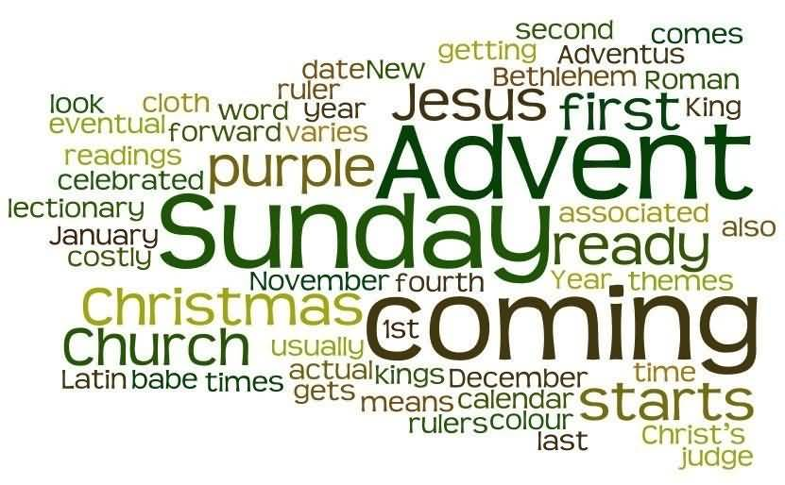 |  | - Merry Christmas to all of our Families  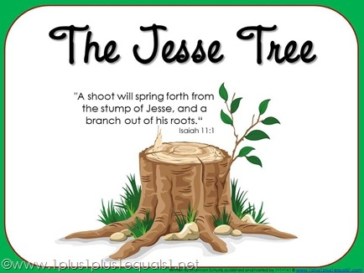
we are called to love and be loved |  | Holidays: Dec.23-Jan. 8
Poster and Literary 2017 Competition #99 Royal Canadian Legion Winners!!
B & W Poster: Harlee Irvine (1st)
Maya Bianchi (3rd)
Colour Poster: Abeecha Maher (1st)
Emma Pinchin (2nd)
Christmas Concert Schedule
December 20th
Classes participating: Pilon, Baxby, Mahoney, Lavoie, Dupuis, Richardson, Normington-Michell, Whalen, Shrider, McCoy, Burtch, Sabean, Nabine, Martin
December 21st
Classes participating: Callaghan, Ross, Lee, Seamont, Mulvihill, Levesque, MacGillivary, Griffiths, Durkin, Ross, Carmichael, Hartnell, Dowdall
Both concerts to be held at Nicholson Catholic College at 5:45 pm.

Cereal and Snack Drive
A huge thank you for everyone who supported the cereal and snack drive in November!

Join Us for Our Weekly Advent Liturgies
Mon., Dec. 4th
Mon., Dec. 11th
Mon., Dec. 18th
8:45 am in the school gymnasium
Cinderella Production is coming to St. Michael!

Wednesday, December 6th
8:45 a.m.

GRADE 8
Nicholson Catholic College
“Integration Day”
December 6th
Catholic School Council Association Meeting
December 7th
6:30-8:00

Catholic parent council
Please consider joining our Catholic School Council. We are always looking for new members and all are welcome to attend! Next meeting will be November 1st at 5:30 pm. Child care provided.
Christmas Tree and Wreath Delivery!!
December 4th
Victoria Street Entrance

SANTA CLAUS PARADE
2017
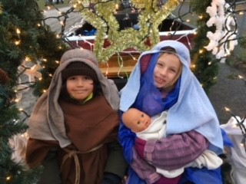

We had a really great time decorating and riding on the float for the Santa Claus Parade. A special thanks to all of the students, parents, and staff who helped make our float festive!

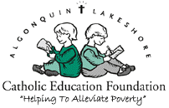
Algonquin and Lakeshore Catholic Education Foundation is a registered charity that raises funds and provides financial support to assist families within our schools during times of crisis or poverty. This assistance may include the provision of eye glasses, medical supplies, accommodations, food, clothing, or transportation. For more information, go to:
http://www.alcdsb.on.ca/Board/Pages/Foundation.aspx

Technology in Education – It’s Important!
What do I need to know about effective use of technology to support student learning? In a recent survey, CISCO announced that “more than ¾ of top educational officials around the world believe technology can play a major role in how students learn and how teachers educate.” Preparing students to compete in a global economy and expanding their ability to use technology wisely, competently, and effectively is now a major requirement for school boards. Changes in technology are occurring so rapidly and within such a range of contexts that it is very difficult for educational leaders to keep abreast of the effective use of technology and its broad scope to impact on student learning and teacher instruction. The Partnership for 21st Century Skills, 2006 maintains that there is a gap between what students learn in school and the knowledge and skills they need for their future. As chief education officers, directors have a responsibility and a mandate to create a dynamic school system that uses technology to build engaging, media-rich learning experiences and enhance student-centred instruction (excerpt taken from : JUNE 30, 2011 • ADVISORY NO. 3, Council of Ontario Directors of Education)
School Masses on December 15th
Primary: 8:30-9:30
Junior/Intermediate: 9:45-10:45
Breakfast Club volunteers needed 8:00-8:45 am.
Please consider joining a team of volunteers that helps to feed dozens of students each morning. rning per week.

Youth News!
Thanks to our supporters: NCC Corporation, CWL, Knights, Jim’s Pizzeria
Advent Candles for Sale! Grade 6,7 and 8 students from St. Michael’s and OLF schools have prepared Advent candles as a service to our community. Candles available at the Welcome desk.
Cost: $5/set
UPCOMING TEEN ACTIVITIES for QUINTE CATHOLIC YOUTH!
Grade 7 NET RETREAT: all Confirmation candidates and Parish students in Grade 7 are invited to attend our NET Retreat, being held in the Parish Hall on Tuesday, Nov. 28th, from 9:30am-2pm. Students attending St. Michael’s and OLF schools will come with their classes. Parish students not attending those schools are welcome to attend. Please notify the Youth office.
GOSPEL ADVENTURES! 1ST SUNDAY of each MONTH
All Teens Welcome! (in the CAVE)
December: Service and community opportunity hours available for Confirmation preparation and for high school students!
CHRISTMAS SHARING
Classes will collect donations to provide Christmas dinner for families in need. We will be providing food for 26 families in our community.
Teachers will ask for specific items for the basket plus $2.00 to put towards a turkey starting mid December ( we are registered but will not be given our families until late this week or early next week).
We are looking for volunteers to deliver the food the morning of Wednesday December 20 starting at 9:30. If able to volunteer please call the school and leave a message for Ms. Callaghan or Ms. Sabean.
Dec. 3rd ADVENTURE #4: FOOD FOR THE GIVING 6:30-9pm
Christmas Bakin’ & Chili Makin’ for our Christmas Hamper Family. Bring your favourite Gingerbread decorations!
Dec. 17th ADVENTURE #5: DELIVER CHRISTMAS SHARING 6:30-8:30pm
followed by hot chocolate and treats at Tim Horton’s. Meet @ Cave, pick-up @ Timmy’s on Sidney.
CANADIAN FOOD For CHILDREN: Thank you for your donations. Our collection of Salt, Sugar and Split peas for the needy is ongoing.
EVERY SCHOOL DAY COUNTS
This holiday season, the best gift you can give your child is a good education. And the best place to get that education is in school. Every day. On time.
• Every year, absences spike in the weeks before and after winter break. It’s time to break that cycle.
Just a few missed days here and there, even if they’re excused absences, can add up to too much lost learning time and put your child behind in school. This is as true in kindergarten as it is in high school.
If missing school is unavoidable, talk to your children’s teachers in advance to create a plan for making up missed work. But remember, a homework packet cannot make up for the interaction and learning that goes on in the classroom.
• So give your child the gift of attendance and help build a habit of attendance.

Christmas SPIRIT Week – Dec. 18th-21st
MONDAY - Merry Monday – Wear Christmas PJ’s
TUESDAY – Crazy Christmas Sock Day
WEDNESDAY – Christmas Sweater/Spirit Wear
THURSDAY – Crazy Christmas Hair Day
FRIDAY – Flannel Friday

